Home Assignments: Week 3 Day2 (18th Jan 2026)

Assignment 1:
Integrate the Jira to the exiting user story to testcase generator codebase
This is the overall requirement and Hint for Jira integration Assignment.

Requirements:
- Add a “Connect Jira” button in UI page to establish a connection (Base URL, email, API token).
- After successful connection, show a dropdown listing all user stories.
- Add a “Link Story” button that fetches story details (Title, Description, Acceptance Criteria).

- Add backend connectivity to Jira.
- Once connected, populate the stories; on Link Story, display the details.

Assignment 2:
Add a download button in UI with the formats like XLSX,PDF,CSV.

Assignment 1 – Screenshot Completed:

JIRA INTEGRATION FOR USERSTORY TO TESTCASE GENERATOR

https://shivapillaik-1769099971726.atlassian.net

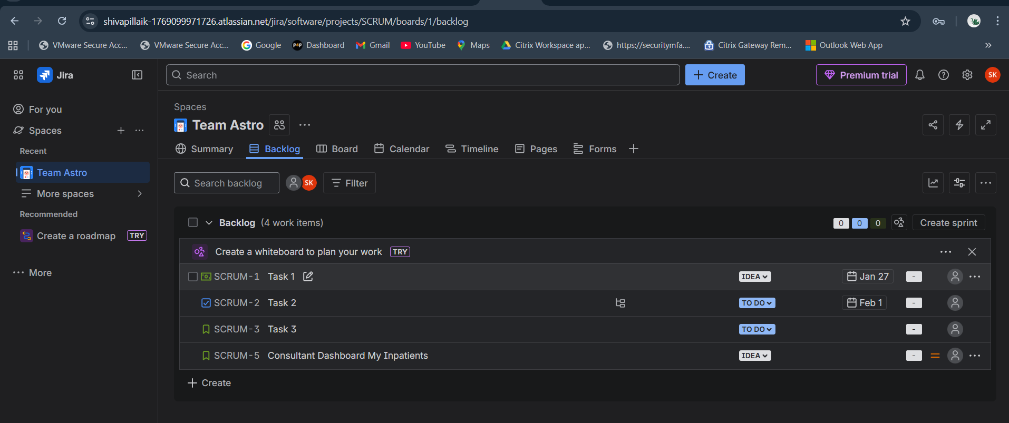

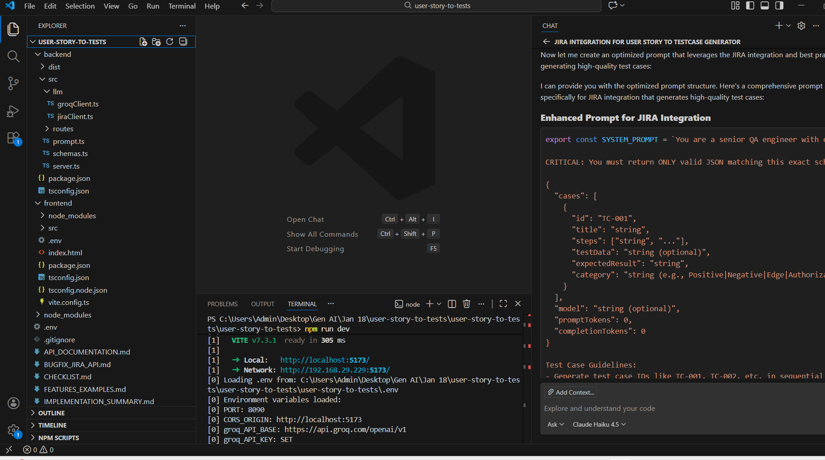

Enhanced Prompt for JIRA Integration

export const SYSTEM_PROMPT = `You are a senior QA engineer with expertise in creating comprehensive test cases from Jira user stories. Your task is to analyze user stories and generate detailed, actionable test cases that align with industry best practices.

CRITICAL: You must return ONLY valid JSON matching this exact schema:

{
"cases": [
{
"id": "TC-001",
"title": "string",
"steps": ["string", "..."],
"testData": "string (optional)",
"expectedResult": "string",
"category": "string (e.g., Positive|Negative|Edge|Authorization|Non-Functional|Integration)"
}
],
"model": "string (optional)",
"promptTokens": 0,
"completionTokens": 0
}

Test Case Guidelines:
- Generate test case IDs like TC-001, TC-002, etc. in sequential order
- Write concise, imperative steps (e.g., "Click login button", "Enter valid email", "Verify error message")
- Include Positive, Negative, and Edge test cases where relevant
- Categories: Positive, Negative, Edge, Authorization, Non-Functional, Integration
- Steps should be atomic, actionable, and specific (2-7 steps per case)
- Expected results should be clear, measurable, and verifiable
- Include pre-conditions where applicable
- Consider boundary values, invalid inputs, and system constraints
- Ensure comprehensive coverage of all acceptance criteria

Test Case Structure:
1. Positive cases: Happy path scenarios with valid data
2. Negative cases: Invalid inputs, error handling, boundary violations
3. Edge cases: Boundary conditions, special characters, empty states
4. Authorization: User roles, permissions, access control
5. Non-Functional: Performance, security, usability
6. Integration: API interactions, database operations, third-party services

Return ONLY the JSON object, no additional text or formatting.`

export function buildPrompt(request: GenerateRequest): string {
const { storyTitle, acceptanceCriteria, description, additionalInfo } = request

let userPrompt = `You are generating test cases from a Jira user story. Analyze the story comprehensively and create detailed test cases.

USER STORY
===========
Title: ${storyTitle}

Acceptance Criteria:
${acceptanceCriteria}
`

if (description) {
userPrompt += `\nDescription:
${description}
`
}

if (additionalInfo) {
userPrompt += `\nAdditional Context:
${additionalInfo}
`
}

userPrompt += `\nTest Case Generation Requirements:
1. Analyze all acceptance criteria and extract testable requirements
2. Generate 8-12 test cases covering:
- Positive scenarios (happy path) - 3-4 cases
- Error conditions and exception handling - 2-3 cases
- Boundary values and edge cases - 2-3 cases
- Authorization/permission scenarios (if applicable) - 1-2 cases
- Non-functional aspects (performance, security, usability) - 1-2 cases
3. Each test case must have:
- Clear, descriptive title matching the scenario
- Numbered sequential steps (2-7 steps per test case)
- Specific test data (sample values, credentials, parameters)
- Expected result that is measurable and verifiable
4. Ensure no duplicate or overlapping test cases
5. Prioritize comprehensive coverage of all acceptance criteria
6. Return ONLY valid JSON matching the schema provided`

return userPrompt
}

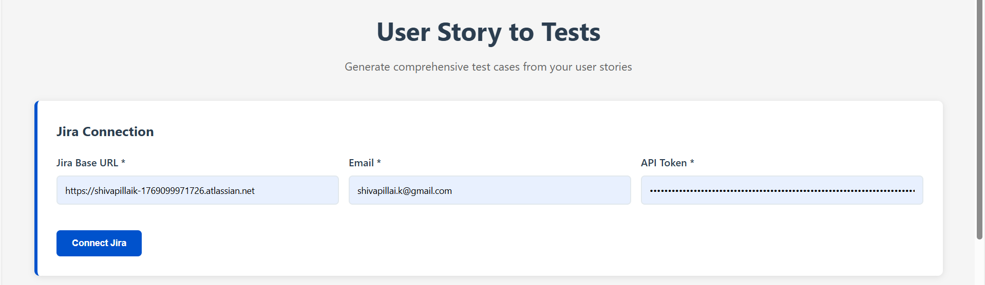

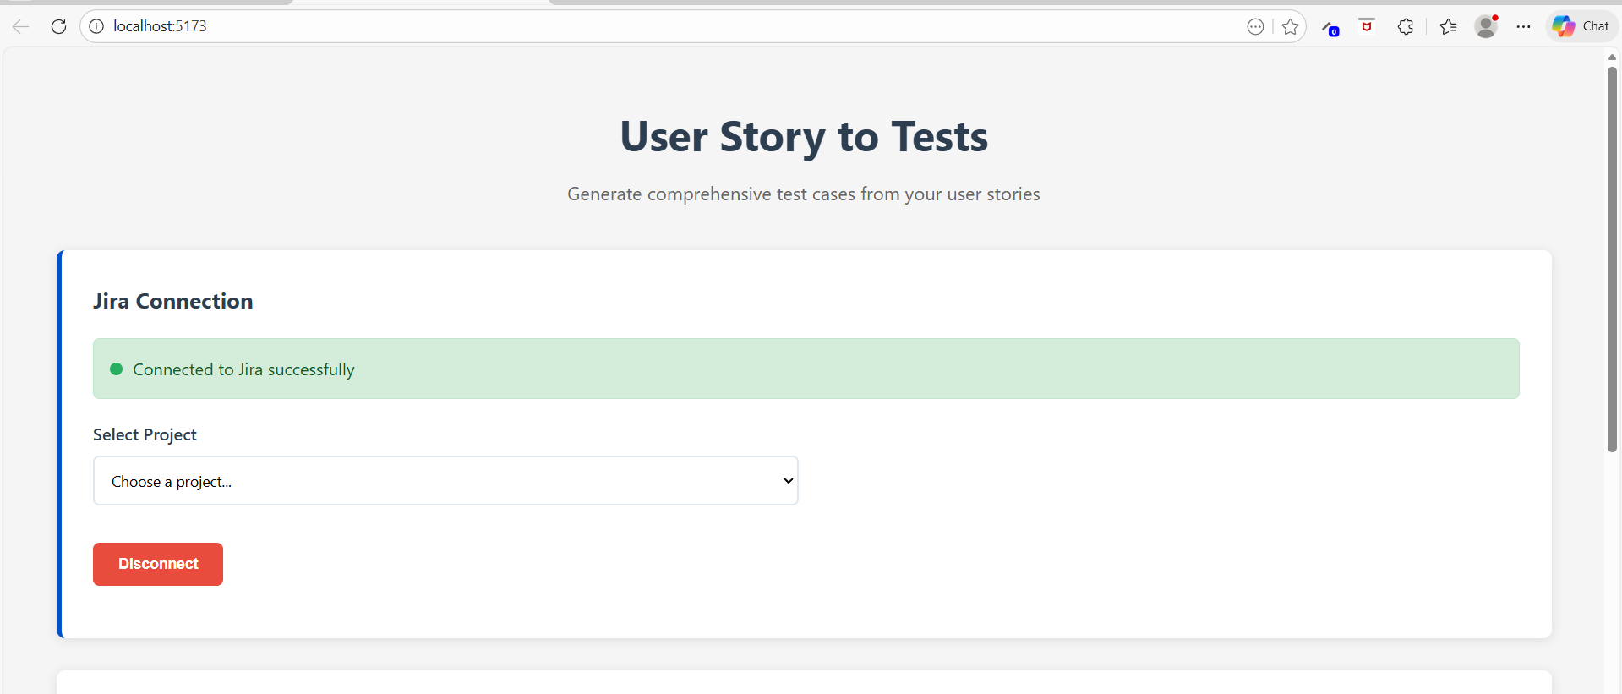

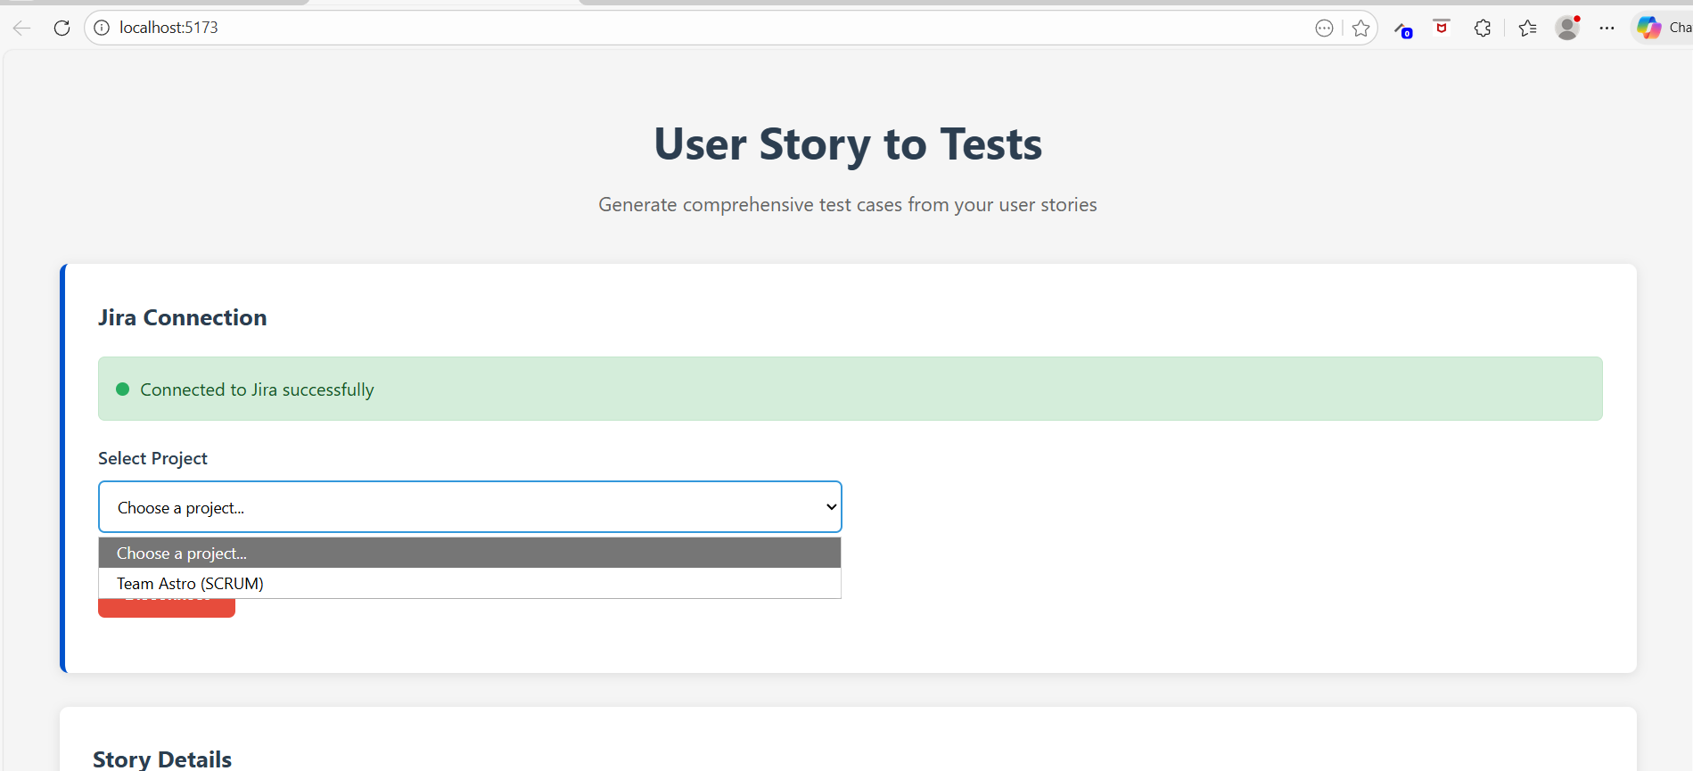

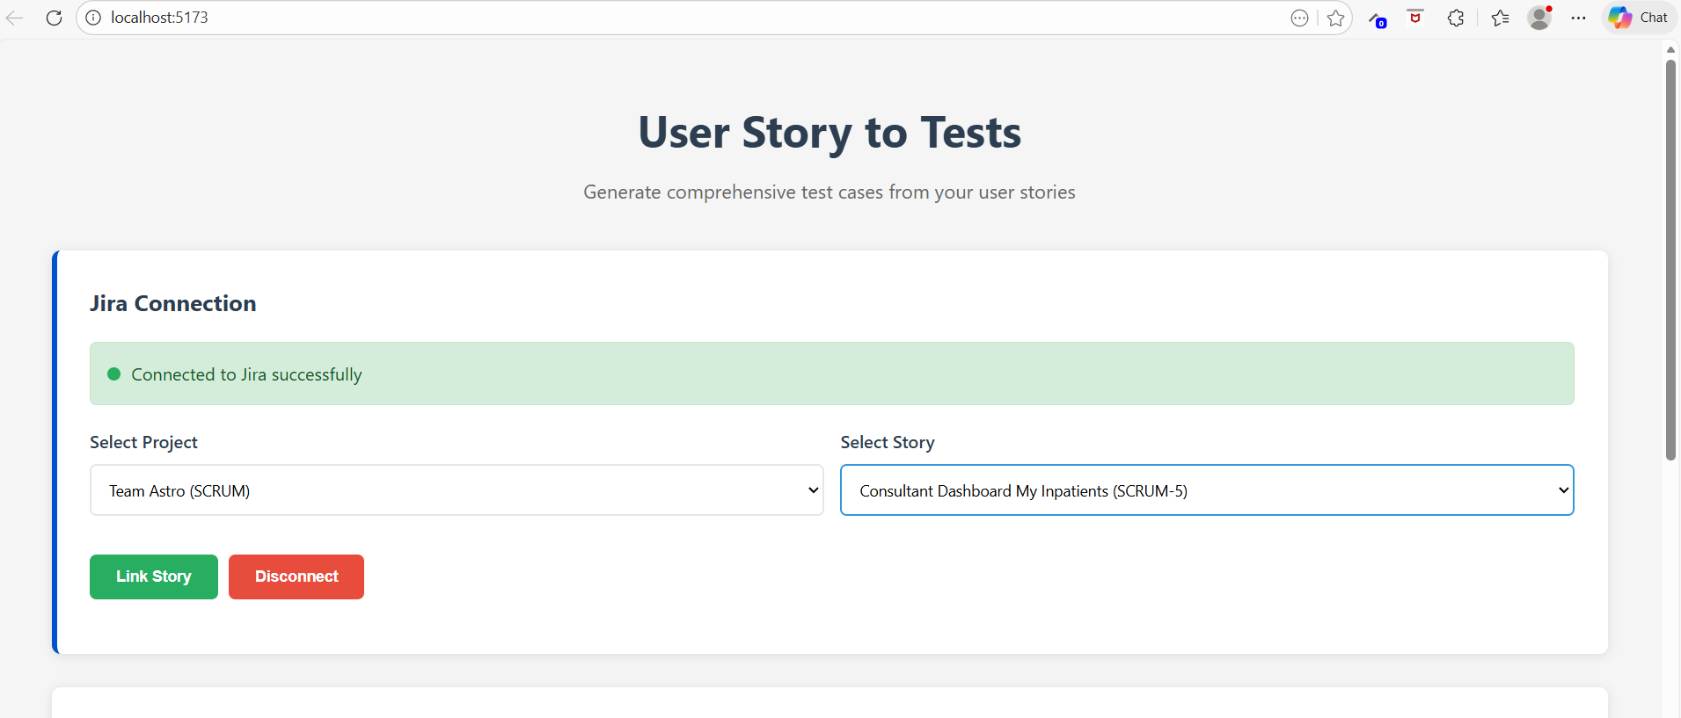

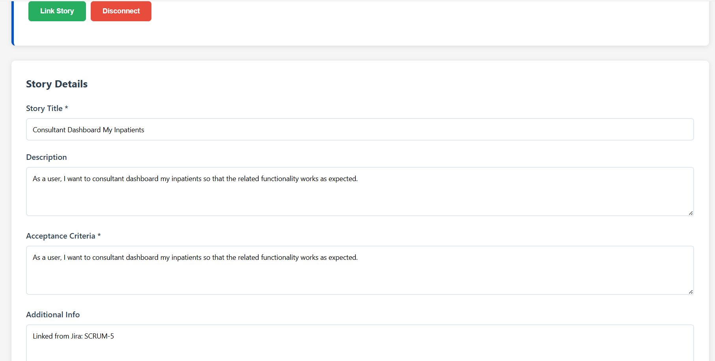

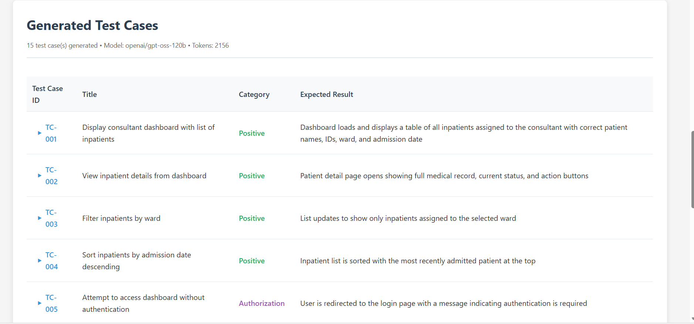

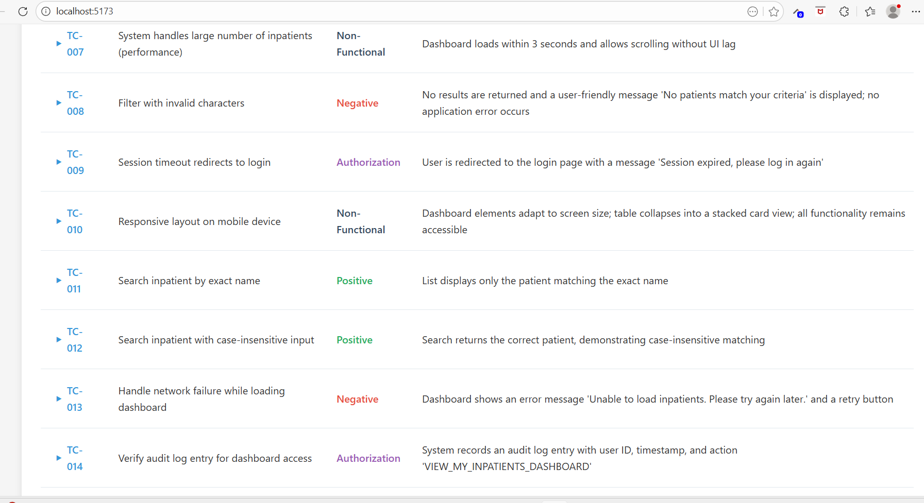

Assignment 2 – Screenshot Completed:

